GTB  
  
**QA**  
[DEV 20.12] OT-835 | AB | IT | SHOWROOM | Primary Vehicles – 30 March 2020

**Jira ticket:**  
<https://jira.uhub.biz/browse/GTBEMEAOPT-835>

**Site**  
<https://www.ford.it/>

**Test location**  
Multiple

**Tags**

CONTROL - tt:nwp:opt-835:ab:vsr:primary-vehicles:control

CHALLENGER - tt:nwp:opt-835:ab:vsr:primary-vehicles:challenger

**Hypothesis**  
By seeing the vehicles first, customers are more likely to visit the page, BnP or TDR the vehicle

**Test Description**  
Although all these tests start with “View the CHALLENGER link”, you don’t have to close and re-open the browser. If you already have it open, you can skip that point.

ALL PAGES TEST: View the CHALLENGER Link. You can do this test on every page. At the top of the screen mouse over “GAMMA” this will open the “GAMMA” Menu with several sub options and several vehicles underneath those options. Depending on the sub option chosen, different vehicles will be displayed. For this test we’re only looking at the “Tutte le vetture” sub-option. The first three should be the “NUOVA PUMA”, “MUSTANG MACH-E" and “NUOVA KUGA”, followed by the order it’s in normally (View Control as Example), except that Puma, Mach-E and Kuga are right in the front now.

The below image is taken from the CONTROL:

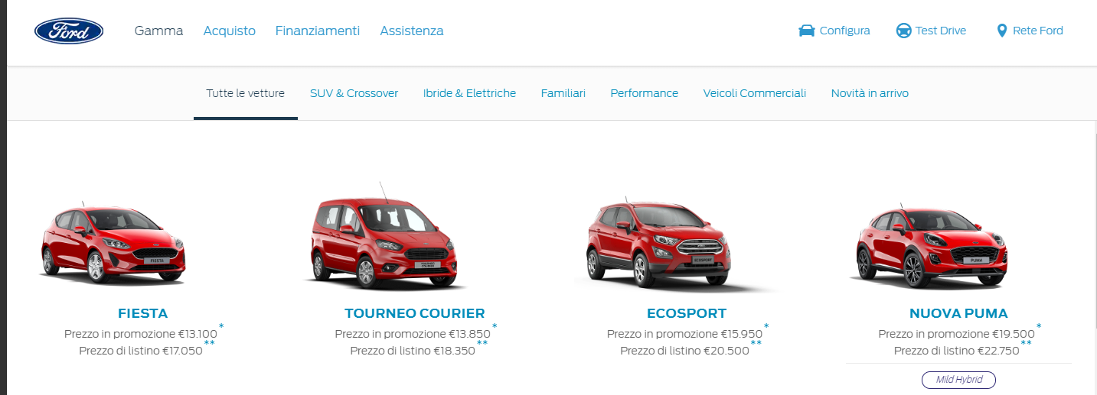

The below image is taken from the CHALLENGER:

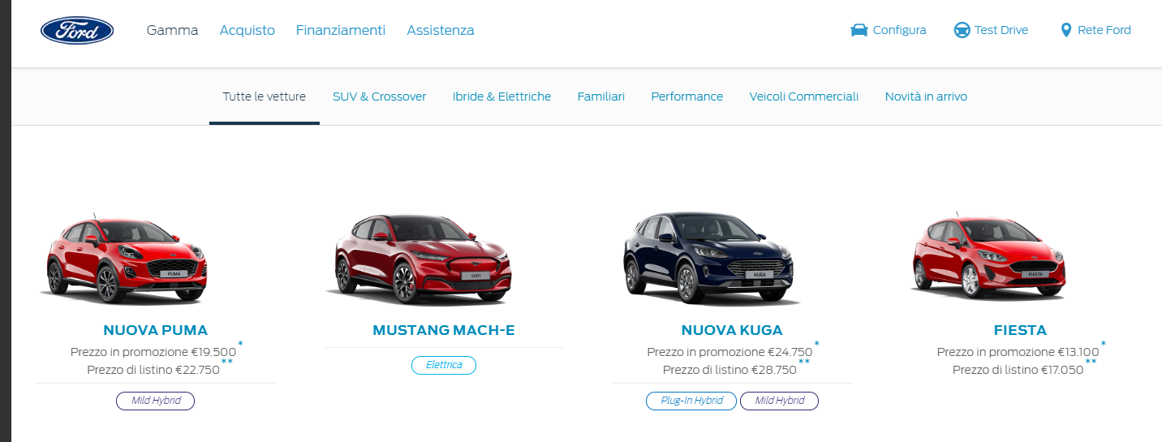

HOME PAGE TEST: View the CHALLENGER link. On the home page scroll down to the heading that says “Un veicolo per ogni stile di vita”. Below it should be a container with cars with the sub option “Tutte le vetture” selected. The first three should be the “NUOVA PUMA”, “MUSTANG MACH-E" and “NUOVA KUGA”, followed by the order it’s in normally (View Control as Example), except that Puma, Mach-E and Kuga are right in the front now.

The below image is taken from the CONTROL:

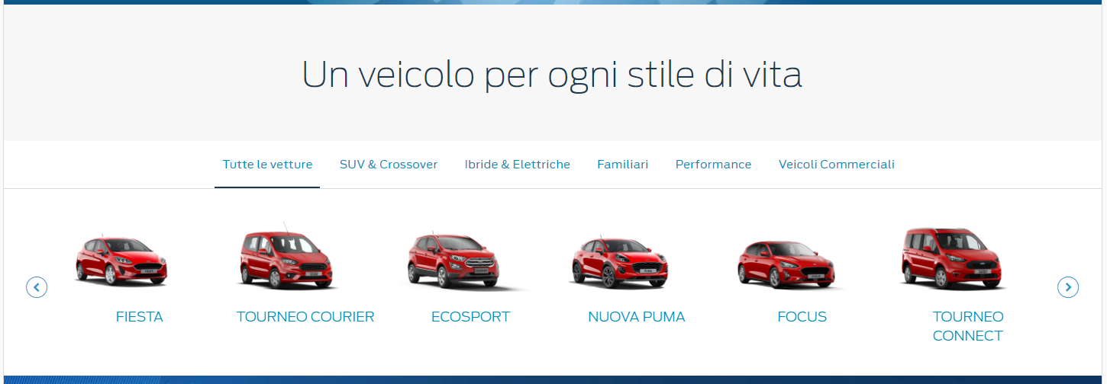

The below image is taken from the CHALLENGER:

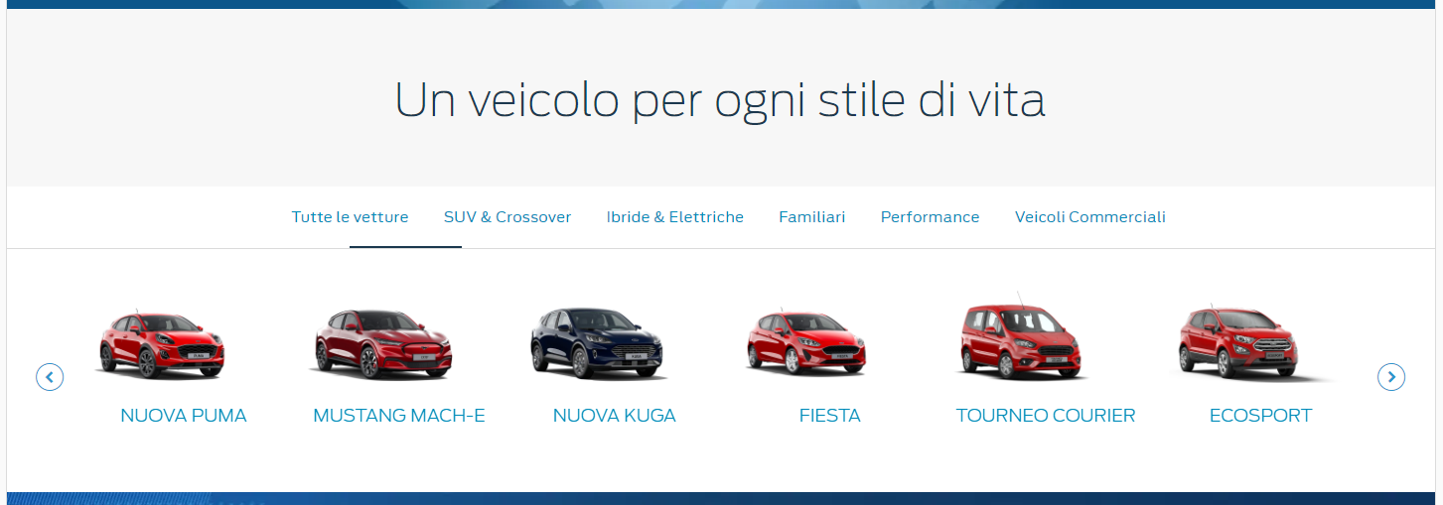

As you can see when comparing the CONTROL and CHALLENGER, after the updated changes the list follows the same order as it was in CONTROL, however on the CHALLENGER the vehicle after the ECOSPORT would be the FOCUS not the NUOVA PUMA.

"Ibride & Elettriche" has been added to the test. Once you've clicked on it, the first three should be "NUOVA PUMA", "MUSTANG MACH-E" and "NUOVA KUGA", followed by the "MONDEO" and the "NUOVO EXPLORER".

The below image is taken from the CONTROL:

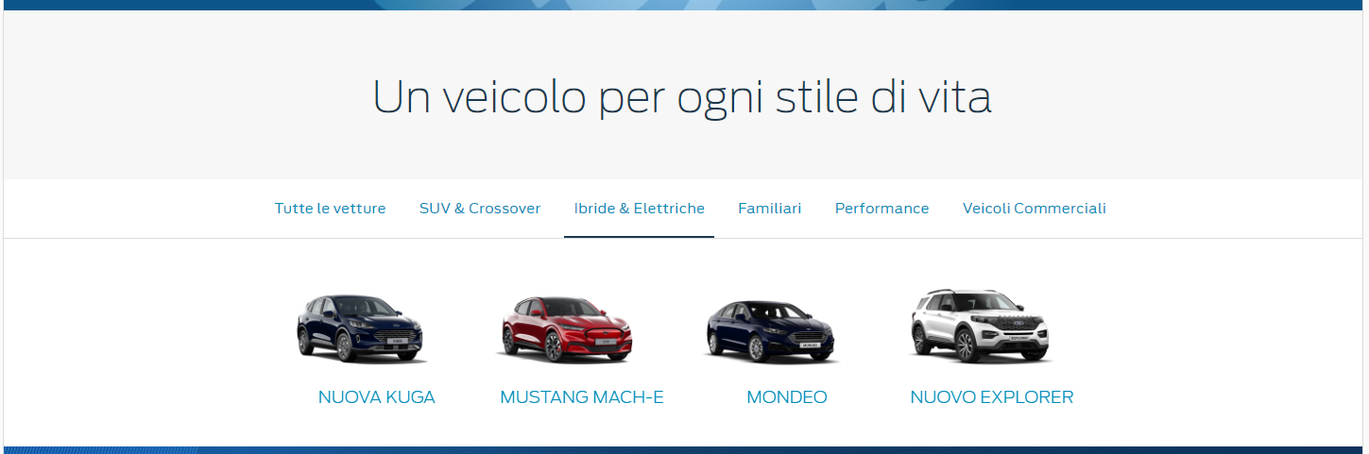

The below image is taken from the CHALLENGER:

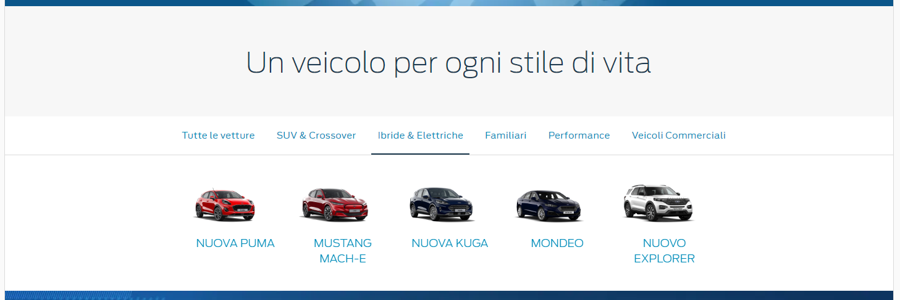

SHOWROOM TEST: View the CHALLENGER link. At the top of the screen mouse over “Acquisto” then on the left select “Vetture” under the “Ricerca” heading. The first three should be the “NUOVA PUMA”, “MUSTANG MACH-E" and “NUOVA KUGA”, followed by the order it’s in normally (View Control as Example), except that Puma, Mach-E and Kuga are right in the front now.

The below image is taken from the CONTROL:

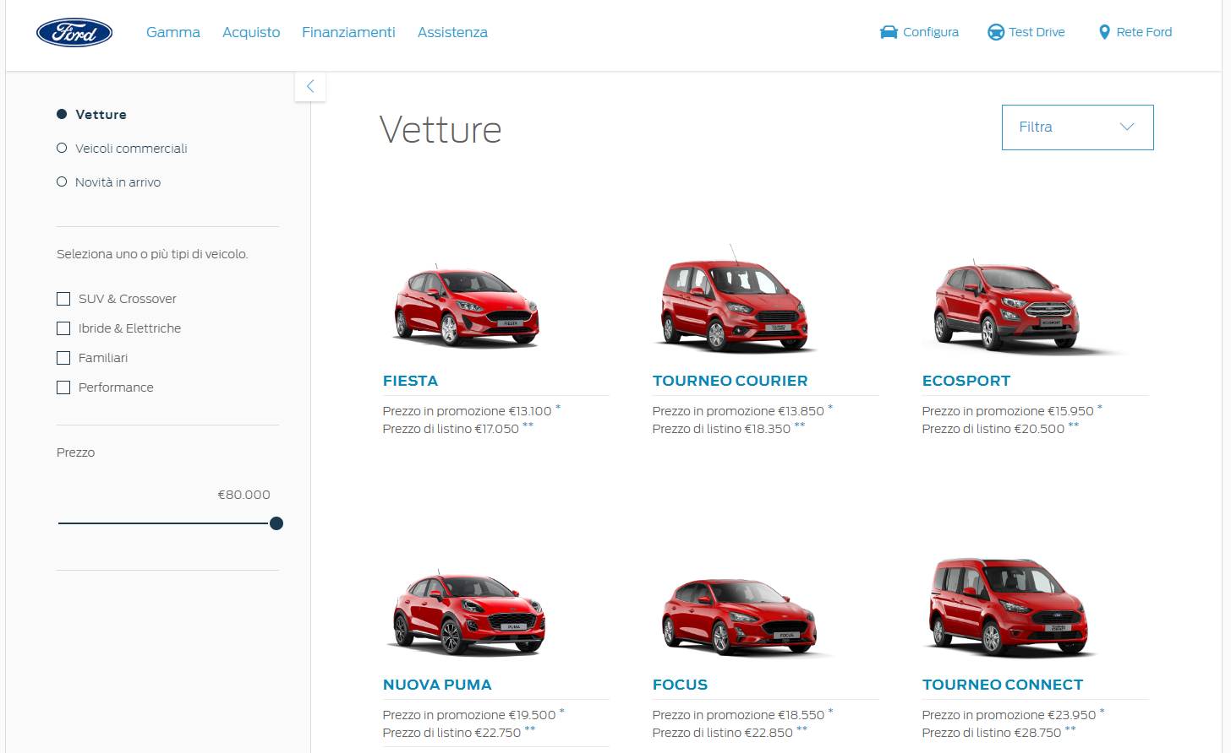

The below image is taken from the CHALLENGER:

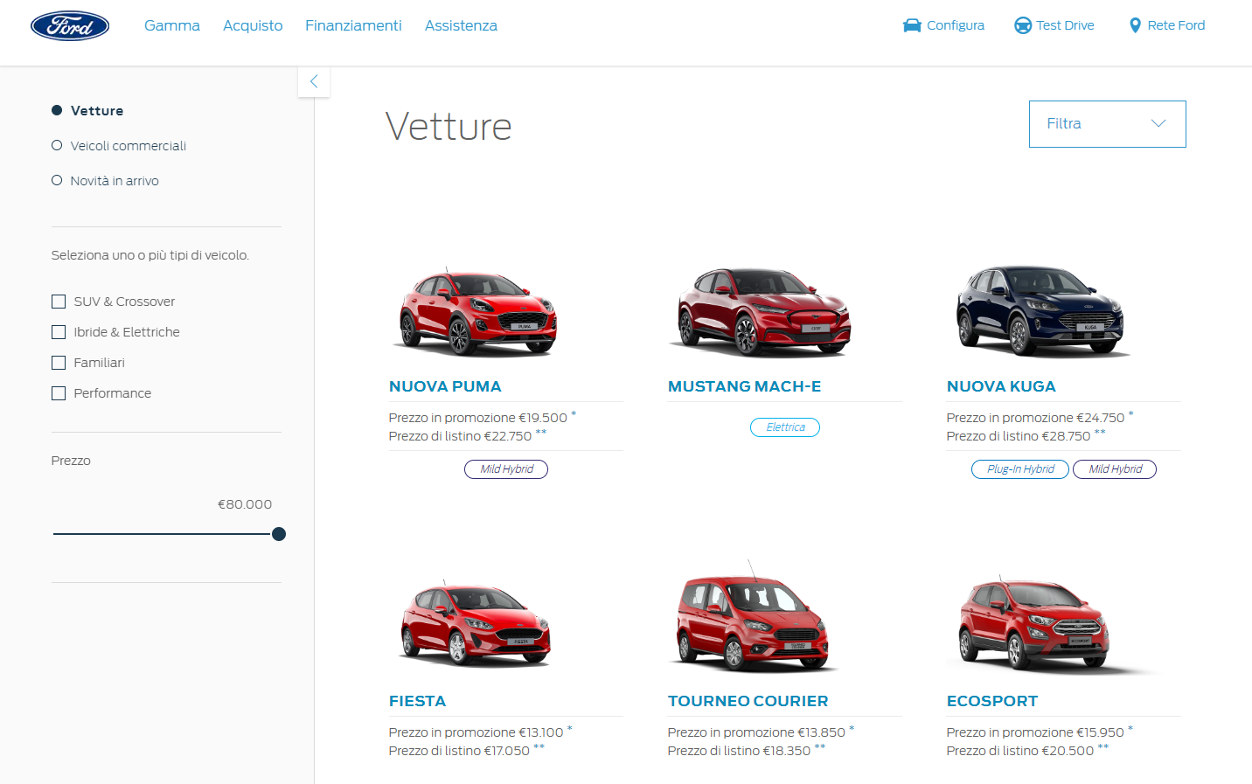

BNP SHOWROOM TEST: View the CHALLENGER link. At the top of the screen click on the “Configura” link. It’s on the right, has a little car next to it. The first two should be the “NUOVA PUMA” and “NUOVA KUGA”, followed by the order it’s in normally (View Control as Example), except that Puma and Kuga are right in the front now. This page does not feature the “MUSTANG MACH-E".

The below image is taken from the CONTROL:

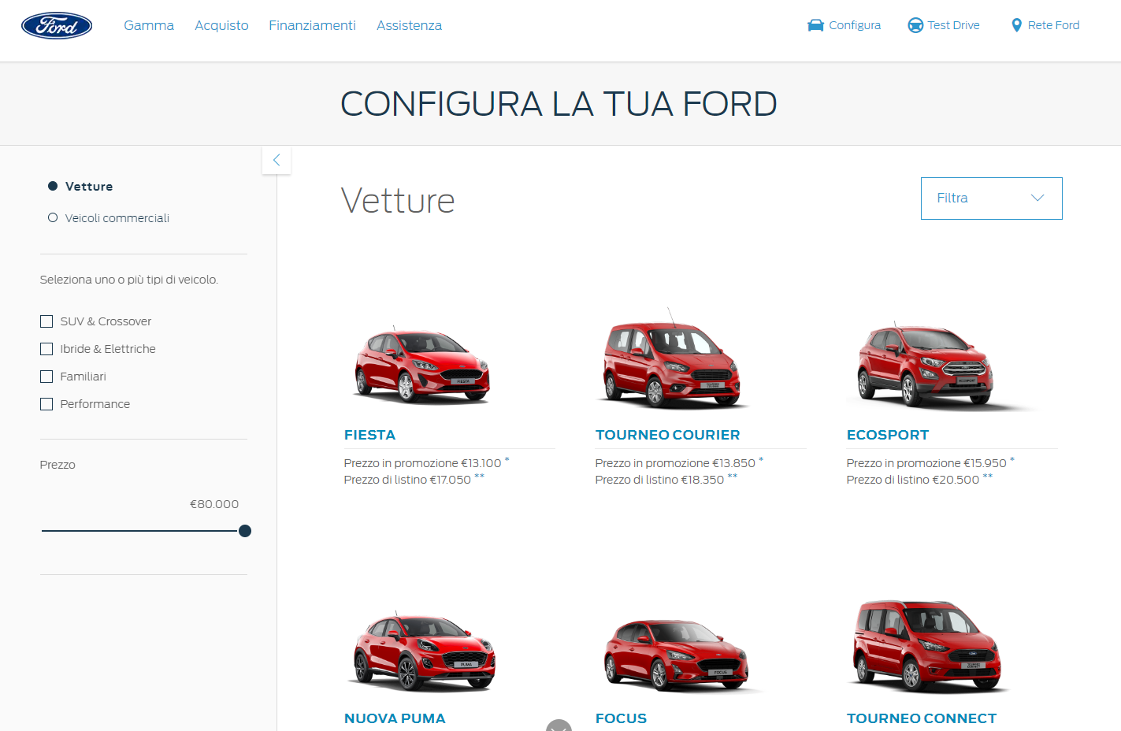

The below image is taken from the CHALLENGER:

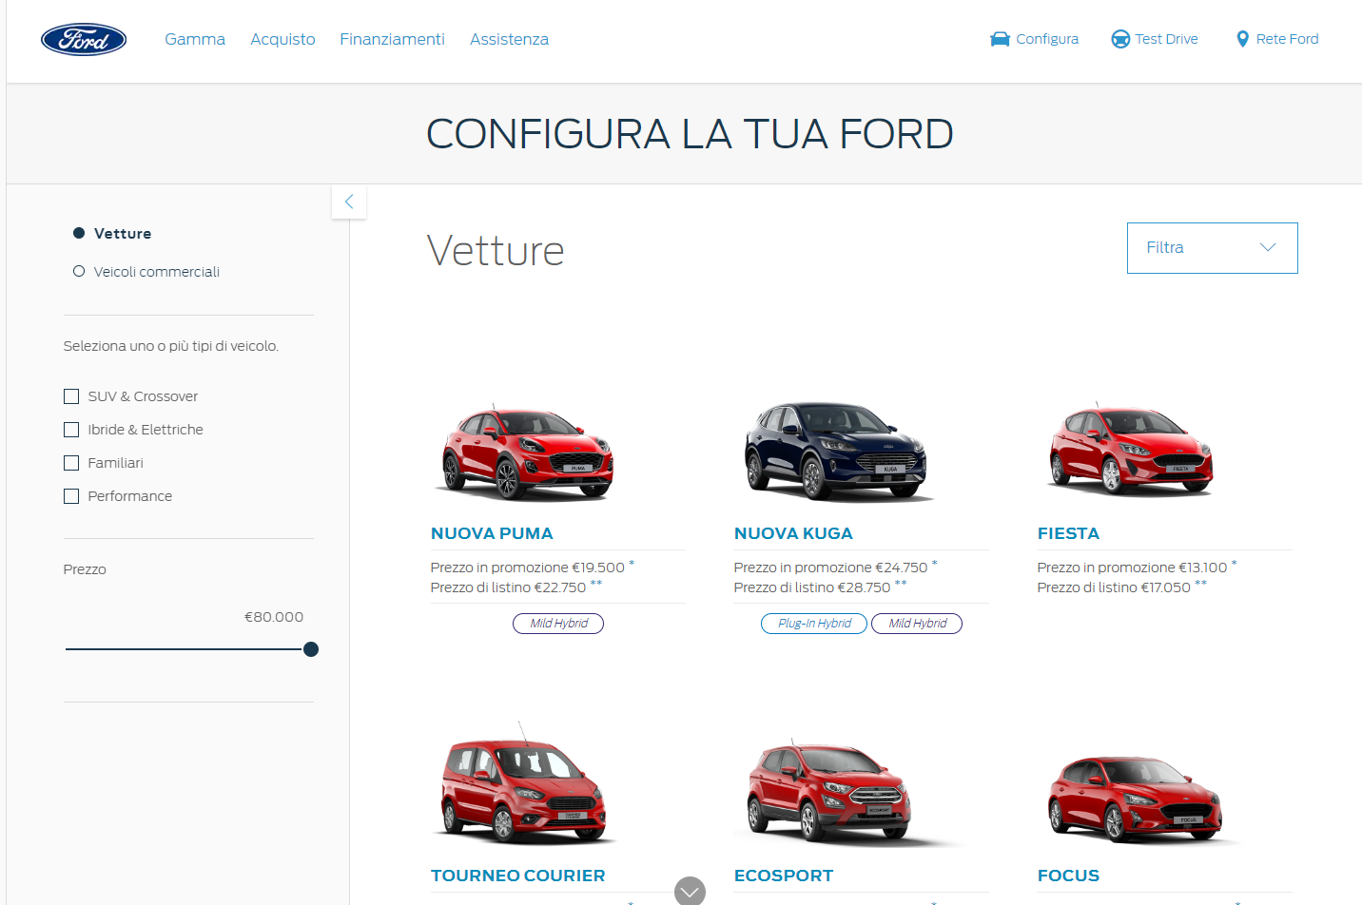

HEV LANDING PAGE TEST: View the CHALLENGER link. At the top of the screen mouse over “Acquisto” then on the left select “Veicoli Ibridi ed Elettrici” under the “Ricerca” heading. There are 2 components on this page that contains 6 cars in total. The first is underneath the “BRING ON TOMORROW” section close to the top. The second is far to the bottom after a section with information on the NUOVA KUGA. Both of these sections should contain the following changes. The first three should be the “NUOVA PUMA”, “MUSTANG MACH-E" and “NUOVA KUGA”, followed by the order it’s in normally (View Control as Example), except that Puma, Mach-E and Kuga are right in the front now.   
  
The below image was taken from the CONTROL:

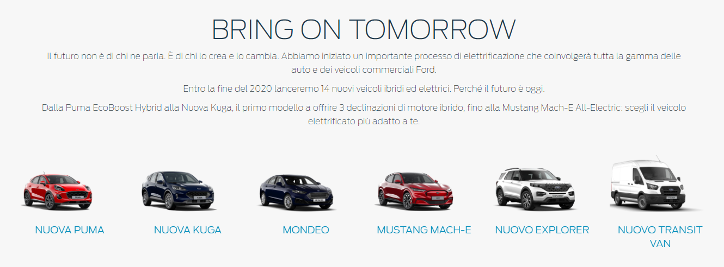

The below image was taken from the CHALLENGER:

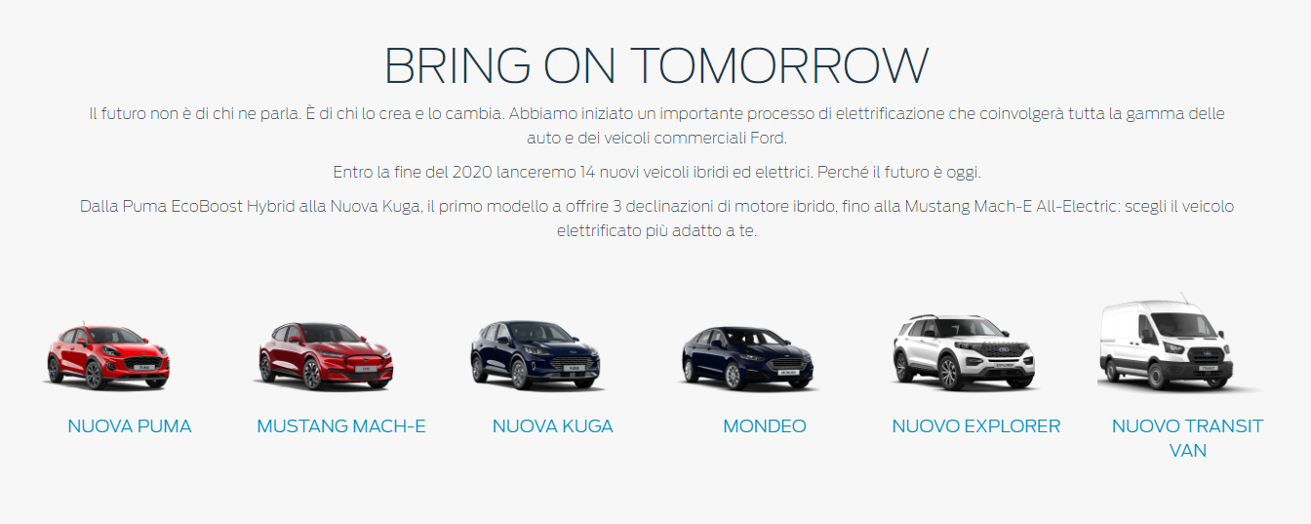

**Browser:**   
All  
  
**Device:**   
All  
  
**Audience rules:**   
All traffic

**QA Links:**

**CONTROL:**

<https://www.ford.it?at_preview_token=t4JfLovIgv7g1sRR4iZHPQ%3D%3D&at_preview_index=1_1&at_preview_listed_activities_only=true>

**CHALLENGER:**

<https://www.ford.it?at_preview_token=t4JfLovIgv7g1sRR4iZHPQ%3D%3D&at_preview_index=1_2&at_preview_listed_activities_only=true>